**Transfer Learning-Based Classification of Poultry Diseases for Enhanced Health Management** **Project Report**

# 1. INTRODUCTION

## 1.1 Project Overview

The poultry industry often faces significant losses due to undetected or late-detected diseases. This project aims to implement a transfer learning-based system capable of classifying poultry diseases from images (focusing on skin, feathers, and beak) to enable early detection and reduce dependency on veterinary intervention.

## 1.2 Purpose

To design and deploy a deep learning-powered poultry disease detection system using transfer learning. The solution will enhance decision-making for farmers, improve poultry health management, and contribute to economic and food security.

# 2. IDEATION PHASE

## 2.1 Problem Statement

| Date |  |
| --- | --- |
| Team ID | LTVIP2025TMID33973 |
| Project Name | Transfer Learning-Based Classification of Poultry Diseases for Enhanced Health Management |
| Maximum Marks | 2 Marks |

| PS-1 | a poultry farmer or poultry farm manager | maintain the health of my poultry and detect diseases at an early stage | manual diagnosis based on visual symptoms is often inaccurate and delayed | it depends on human judgment and requires veterinary intervention, which may not always be available promptly | worried about losing livestock, financially stressed due to treatment costs and losses, and uncertain about flock health management |
| --- | --- | --- | --- | --- | --- |
| PS-2 | a veterinarian or livestock health officer | provide timely and accurate disease diagnosis for poultry | frequent misreporting or late reporting of symptoms by farmers hinders early intervention | farmers are not trained to recognize early signs or patterns of specific poultry diseases | concerned about preventable disease spread and frustrated by inefficient case handling |

Poultry farmers experience major financial losses due to delayed or incorrect disease detection. Manual identification is error-prone, slow, and dependent on veterinary availability, especially in rural regions.

## 2.2 Empathy Map Canvas

| Date |  |
| --- | --- |
| Team ID | LTVIP2025TMID33973 |
| Project Name | Transfer Learning-Based Classification of Poultry Diseases for Enhanced Health Management |
| Maximum Marks | 4 Marks |

An empathy map is a simple, easy-to-digest visual that captures knowledge about a user’s behaviours and attitudes.

It is a useful tool to helps teams better understand their users.

Creating an effective solution requires understanding the true problem and the person who is experiencing it. The exercise of creating the map helps participants consider things from the user’s perspective along with his or her goals and challenges.

## Empathy Map – Target User: Poultry Farmer

|  |  |  |
| --- | --- | --- |
|  | 🧠 **Thinks** - I must keep my poultry healthy to avoid losses. - I wish there was a quick and reliable way to detect diseases. - I can’t always wait for the vet. - Late detection means major financial loss. |  |
| 👀 **Sees** - Sick birds among healthy ones - Delayed visits from vets - Online content about poultry diseases - Rising costs of medicines and vet care | **USER** | 🗣 **Says** - “This disease spread too fast.” - “I couldn’t recognize it in time.” - “I need help managing flock health.” - “Getting a vet every time is not practical.” |
| 💭 **Feels** - Anxious about flock safety - Frustrated by repeated losses - Helpless when unable to diagnose early - Hopeful for tech-based solutions | 👂 **Hears** - Advice from fellow farmers - Suggestions from local suppliers or vets - News about disease outbreaks - Govt/NGO training (if any) | 🛠 **Does** - Monitors poultry manually - Tries home remedies or basic meds - Calls a vet only when symptoms worsen - Relies on prior experience or guesswork |

## 2.3 Brainstorming

| Date |  |
| --- | --- |
| Team ID | LTVIP2025TMID33973 |
| Project Name | Transfer Learning-Based Classification of Poultry Diseases for Enhanced Health Management |
| Maximum Marks | 4 Marks |

Brainstorming provides a free and open environment that encourages everyone within a team to participate in the creative thinking process that leads to problem solving. Prioritizing volume over value, out-of-the-box ideas are welcome and built upon, and all participants are encouraged to collaborate, helping each other develop a rich amount of creative solutions.

Use this template in your own brainstorming sessions so your team can unleash their imagination and start shaping concepts even if you're not sitting in the same room.

**Step-1: Team Gathering, Collaboration and Select the Problem Statement**

**Problem Statement**:  
Poultry farmers suffer losses due to delayed or inaccurate manual disease detection. This project aims to develop a model using transfer learning to identify poultry diseases early and accurately through image analysis.

**Step-2: Brainstorm, Idea Listing and Grouping**

|  |  |
| --- | --- |
| **Idea Category** | **Ideas Generated** |
| Technology/Tools | - Use pre-trained CNN models like ResNet, MobileNet, or EfficientNet - Develop a mobile/web app interface for image upload - Use TensorFlow Lite for on-device inference |
| User Interaction | - App alerts farmer with disease name and suggested action - Voice assistant or multilingual support |
| Data Collection | - Build dataset from poultry farms (images of infected birds) - Augment data using rotation, zoom, and color shifts |
| Deployment | - Cloud-based API for remote farms with internet access - Offline model for low-connectivity regions |
| Integration | - Link app to vet consultation system or farmer dashboard |
| Awareness/Training | - Video tutorials on using the app - Include image gallery of common poultry diseases for farmer reference |

**Step-3: Idea Prioritization**

|  |  |  |
| --- | --- | --- |
| **Idea** | **Impact (High/Med/Low)** | **Feasibility (High/Med/Low)** |
| Pre-trained model (Transfer Learning) | High | High |
| Mobile/Web-based image analysis app | High | Medium |
| Voice support & regional language options | Medium | Medium |
| Collect and augment poultry disease images | High | Medium |
| Offline deployment for rural areas | High | Medium |
| Veterinary integration (optional) | Medium | Low |
| Farmer training via tutorials | Medium | High |

Ideas included using mobile apps, transfer learning with image classification, multilingual support, offline model access, disease history tracking, and farmer education modules.

# 3. REQUIREMENT ANALYSIS

## 3.1 Customer Journey Map

**Awareness**: Learns about the app  
**Interest**: Looks up details  
**Try**: Installs & tries app  
**Use**: Uploads image for analysis  
**Action**: Follows recommendations  
**Feedback**: Shares experience  
**Retention**: Receives tips  
**Referral**: Shares with other farmers

## 3.2 Solution Requirement

| Date |  |
| --- | --- |
| Team ID | LTVIP2025TMID33973 |
| Project Name | Transfer Learning-Based Classification of Poultry Diseases for Enhanced Health Management |
| Maximum Marks | 4 Marks |

## Functional Requirements

|  |  |  |
| --- | --- | --- |
| FR No. | Functional Requirement (Epic) | Sub Requirement (Story / Sub-Task) |
| FR-1 | User Registration | Registration through Form |
|  |  | Registration through Gmail |
| FR-2 | User Confirmation | Confirmation via Email |
|  |  | Confirmation via OTP (Mobile number) |
| FR-3 | Image Upload | Upload image from gallery |
|  |  | Capture real-time image through camera |
| FR-4 | Disease Detection | Analyze image using pre-trained AI model |
|  |  | Display diagnosis with disease name and confidence score |
| FR-5 | Recommendation Engine | Show relevant suggestions (e.g., isolation, vet visit) |
|  |  | Show similar past cases from history (if any) |
| FR-6 | Language Support | Multi-language UI (English, Hindi, Telugu, etc.) |
| FR-7 | Disease History Log | View previous scans with date, time, and diagnosis results |
| FR-8 | Notifications | Weekly scan reminders |
|  |  | Tips and educational content on poultry health |
| FR-9 | Feedback System | Star rating system |
|  |  | Written or voice-based feedback option |

## Non-functional Requirements

|  |  |  |
| --- | --- | --- |
| FR No. | Non-Functional Requirement | Description |
| NFR-1 | Usability | Interface should be intuitive and accessible for low-literacy users |
| NFR-2 | Security | Data must be encrypted; access control for user accounts |
| NFR-3 | Reliability | The system should maintain at least 95% uptime |
| NFR-4 | Performance | Image analysis and result display should occur in under 5 seconds |
| NFR-5 | Availability | App must be available offline with sync capabilities when internet is restored |
| NFR-6 | Scalability | System should support a growing user base without performance degradation |

Functional requirements include image upload, disease diagnosis, history logs, notifications, multilingual support. Non-functional requirements ensure performance, security, offline access, and scalability.

## 3.3 Data Flow Diagram

| Date |  |
| --- | --- |
| Team ID | LTVIP2025TMID33973 |
| Project Name | Transfer Learning-Based Classification of Poultry Diseases for Enhanced Health Management |
| Maximum Marks | 4 Marks |

**Data Flow Diagrams:**

A Data Flow Diagram (DFD) is a traditional visual representation of the information flows within a system. A neat and clear DFD can depict the right amount of the system requirement graphically. It shows how data enters and leaves the system, what changes the information, and where data is stored

**Data Flow Diagram – Level 0 (Simplified)**

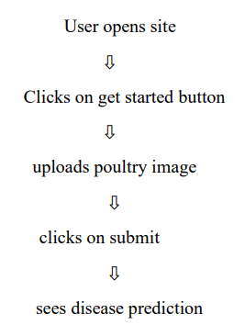 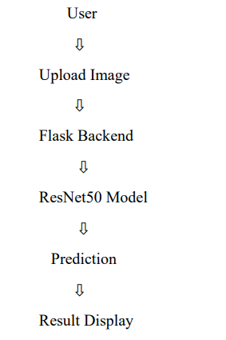

**User Stories**

|  |  |  |  |  |  |
| --- | --- | --- | --- | --- | --- |
| User Type | Functional Requirement (Epic) | User Story Number | User Story / Task | Acceptance criteria | Priority |
| Poultry Farmer | Registration | USN-1 | As a user, I can register using my mobile number or email with a password | I can log in after registering | Sprint-1 |
| Poultry Farmer | Image Upload | USN-2 | As a user, I can upload or take a photo of a sick bird | The image is sent to the backend for processing | Sprint-1 |
| Poultry Farmer | Diagnosis | USN-3 | As a user, I receive the disease name and confidence score | The result is displayed clearly in the app | Sprint-1 |
| Poultry Farmer | Recommendations | USN-4 | As a user, I get advice or remedies after a disease is detected | A list of actions is shown (visit vet, isolation, etc.) | Sprint-2 |
| Poultry Farmer | Language Support | USN-5 | As a user, I can view the app in my local language | I can switch between English and regional language | Sprint-2 |
| Poultry Farmer | Disease History | USN-6 | As a user, I can see previously scanned birds and their diagnosis | I can view a log/history of previous scans | Sprint-2 |
| Poultry Farmer | Notifications | USN-7 | As a user, I receive weekly health tips and scan reminders | I get notifications in-app or via SMS | Sprint-3 |
| Poultry Farmer | Feedback | USN-8 | As a user, I can give feedback or rate the app | A feedback form is submitted successfully | Sprint-3 |

## 3.4 Technology Stack

| Date |  |
| --- | --- |
| Team ID | LTVIP2025TMID33973 |
| Project Name | Transfer Learning-Based Classification of Poultry Diseases for Enhanced Health Management |
| Maximum Marks | 4 Marks |

## Table-1: Components & Technologies

|  |  |  |  |
| --- | --- | --- | --- |
| S.No | Component | Description | Technology |
| 1 | User Interface | Mobile app for image upload and viewing results | Flutter / Android Studio (Java/Kotlin) |
| 2 | Application Logic-1 | Handles image upload and validation | Python (Flask/Django) |
| 3 | Application Logic-2 | Image preprocessing and model inference | Python (OpenCV, TensorFlow/Keras) |
| 4 | Application Logic-3 | Push notifications, health tips | Firebase / Twilio / OneSignal |
| 5 | Database | Stores user data, disease logs | SQLite / PostgreSQL |
| 6 | Cloud Database | Cloud backup of diagnosis records | Firebase Realtime DB / AWS RDS |
| 7 | File Storage | Stores uploaded poultry images | AWS S3 / Firebase Storage |
| 8 | External API-1 | Optional vet integration | TeleVet API (or internal) |
| 9 | External API-2 | SMS Alerts/Reminders | Twilio API / Firebase Cloud Messaging |
| 10 | Machine Learning Model | Transfer learning model to classify poultry diseases | MobileNetV2 / EfficientNet pretrained |
| 11 | Infrastructure | App deployment & model hosting | Local + AWS EC2 / GCP App Engine |

## Table-2: Application Characteristics

|  |  |  |  |
| --- | --- | --- | --- |
| S.No | Characteristics | Description | Technology |
| 1 | Open-Source Frameworks | Libraries and frameworks used | TensorFlow, Keras, Flask, OpenCV |
| 2 | Security Implementations | Data encryption, access controls, auth | JWT, HTTPS, Firebase Auth, SHA-256 |
| 3 | Scalable Architecture | Microservice-ready, backend + model in separate containers | Docker, REST APIs, Kubernetes (optional) |
| 4 | Availability | Multi-region cloud deployment & offline mode support | AWS Multi-AZ, Local Caching |
| 5 | Performance | Fast inference, use of light models, mobile optimization | MobileNetV2, TensorFlow Lite, Load Balancer |

# 4. PROJECT DESIGN

## 4.1 Problem–Solution Fit

|  |  |
| --- | --- |
| Date | 15 February 2025 |
| Team ID | LTVIP2025TMID33973 |
| Project Name | Transfer Learning-Based Classification of Poultry Diseases for Enhanced Health Management |
| Maximum Marks | 2 Marks |

### Problem

Poultry farmers experience major financial losses due to delayed or incorrect diagnosis of diseases in birds. Manual identification based on visual symptoms is often inaccurate and time-consuming, and access to veterinary services is limited in rural areas.

### Target Customer

- Poultry farmers (especially in rural/semi-urban areas)  
- Farm managers and small poultry businesses  
- Veterinary assistants and agricultural extension workers

### Current Behavior (Without the Solution)

- Farmers manually inspect birds for signs of illness  
- Delayed or missed disease detection  
- Often rely on local, unqualified treatment advice  
- Financial losses due to spread of disease and bird deaths

### Pain Points

- Inaccurate or late diagnosis  
- Lack of veterinary access or affordability  
- Fear of outbreaks affecting the whole flock  
- Limited disease knowledge or training

### Proposed Solution

A mobile application that uses AI (transfer learning) to detect poultry diseases from images of birds (e.g., skin, feathers, beak). Farmers can upload a photo, receive instant diagnosis, and get actionable recommendations in local language.

### Benefits / Improvements

- Accurate, real-time disease identification  
- Reduces dependency on veterinary visits  
- Helps prevent spread and loss by early intervention  
- Improves poultry health management and food security  
- Works offline and supports regional languages

## 4.2 Proposed Solution

|  |  |
| --- | --- |
| Date | 15 February 2025 |
| Team ID | LTVIP2025TMID33973 |
| Project Name | Transfer Learning-Based Classification of Poultry Diseases for Enhanced Health Management |
| Maximum Marks | 2 Marks |

|  |  |
| --- | --- |
| Parameter | Description |
| Problem Statement (Problem to be solved) | Poultry farmers often suffer economic losses due to late or inaccurate disease detection. Existing methods rely on manual visual inspection, which is error-prone and slow, especially in rural areas with limited veterinary access. |
| Idea / Solution description | We propose a mobile application powered by transfer learning-based AI models that allows poultry farmers to take or upload images of birds showing symptoms. The app will analyze the images in real-time, identify the disease, and provide actionable health recommendations in local languages. It will also store diagnosis history and work offline with periodic sync. |
| Novelty / Uniqueness | Unlike traditional vet-dependent systems, our solution provides real-time, AI-powered diagnosis from images taken directly by farmers. It supports multiple languages, works offline, and enables farmers with little technical knowledge to manage poultry health independently. |
| Social Impact / Customer Satisfaction | The system empowers rural farmers to detect and respond to poultry diseases early, improving animal welfare, reducing financial loss, and supporting food security. It builds trust by delivering consistent, accessible healthcare guidance. |
| Business Model (Revenue Model) | The app will be free to use with optional premium features such as vet consultation booking, disease forecast analytics, and advanced record keeping. Revenue can also be generated via partnerships with agri-vet companies or rural outreach programs. |
| Scalability of the Solution | The solution is built using scalable cloud infrastructure and lightweight mobile models (e.g., TensorFlow Lite) allowing deployment across different regions, languages, and poultry breeds. It can be expanded to cover other livestock in future updates. |

## 4.3 Solution Architecture

|  |  |
| --- | --- |
| Date |  |
| Team ID | LTVIP2025TMID33973 |
| Project Name | Transfer Learning-Based Classification of Poultry Diseases for Enhanced Health Management |
| Maximum Marks | 4 Marks |

Solution architecture is a complex process – with many sub-processes – that bridges the gap between business problems and technology solutions. Its goals are to:

* Find the best tech solution to solve existing business problems.
* Describe the structure, characteristics, behavior, and other aspects of the software to project stakeholders.
* Define features, development phases, and solution requirements.
* Provide specifications according to which the solution is defined, managed, and delivered.

## Solution Architecture Description

The proposed solution is a mobile-first AI-driven poultry disease detection system. It enables farmers to upload or capture images of their poultry birds via a mobile application. These images are sent to a backend server that leverages a transfer learning-based AI model to identify the disease. The results, including disease name and suggested actions, are returned instantly. The system includes modules for user management, notification alerts, local language support, and offline functionality.

**Key Components:**  
- **Mobile Application:** Allows farmers to capture/upload images and receive diagnosis.  
- **Backend Server:** Built using Python Flask/Django, it manages image processing and user interaction.  
- **AI Model:** A pre-trained transfer learning model (e.g., MobileNet/EfficientNet) fine-tuned on poultry disease datasets.  
- **Database:** Stores user info, image metadata, diagnosis logs (PostgreSQL/Firebase).  
- **Notification Module:** Sends weekly health tips and scan reminders via Firebase Cloud Messaging.  
- **Cloud Infrastructure:** Hosted on AWS/GCP with options for offline support via local caching.

The architecture supports scalability, offline availability, and multilingual accessibility, ensuring wide adoption among rural poultry farmers. The modular design allows future upgrades to support additional livestock or advanced analytics.

**Architecture:**

Mobile App → Backend (Image upload) → AI Model Inference → Database (logs) → Response (diagnosis & recommendation) → Notification System (tips/reminders)

# 5. PROJECT PLANNING & SCHEDULING

## 5.1 Project Planning

|  |  |
| --- | --- |
| Date |  |
| Team ID | LTVIP2025TMID33973 |
| Project Name | Transfer Learning-Based Classification of Poultry Diseases for Enhanced Health Management |
| Maximum Marks | 5 Marks |

**Product Backlog, Sprint Schedule, and Estimation (4 Marks)**

|  |  |  |  |  |  |  |
| --- | --- | --- | --- | --- | --- | --- |
| Sprint | Functional Requirement (Epic) | User Story Number | User Story / Task | Story Points | Priority | Team Members |
| Sprint-1 | Data Collection | USN-1 | As a user, I can collect poultry disease image data from various sources | 2 | High | Saikam Gowtham Varma |
| Sprint-1 | Data Collection | USN-2 | As a user, I can load image data into the system | 1 | High | Saniya Begum |
| Sprint-1 | Data Preprocessing | USN-3 | As a user, I can handle missing values in the dataset | 3 | Medium | Shaik Khaja Parveen |
| Sprint-1 | Data Preprocessing | USN-4 | As a user, I can encode categorical values | 2 | Medium | Saran Susruth Manthri Pragada |
| Sprint-2 | Model Building | USN-5 | As a user, I can build a transfer learning model to classify poultry diseases | 5 | High | Saikam Gowtham Varma |
| Sprint-2 | Model Testing | USN-6 | As a user, I can test the performance of the AI model | 3 | High | Saniya Begum |
| Sprint-2 | Deployment | USN-7 | As a user, I can design basic HTML pages for the interface | 3 | Medium | Shaik Khaja Parveen |
| Sprint-2 | Deployment | USN-8 | As a user, I can deploy the model using Flask framework | 5 | High | Saran Susruth Manthri Pragada |

**Project Tracker, Velocity & Burndown Chart**

|  |  |  |  |  |  |
| --- | --- | --- | --- | --- | --- |
| Sprint | Total Story Points | Duration | Sprint Start Date | Sprint End Date (Planned) | Story Points Completed (as on Planned End Date) |
| Sprint-1 | 8 | 5 Days | 11 JUNE 2025 | 15 JUNE 2025 | 8 |
| Sprint-2 | 16 | 5 Days | 16 JUNE 2025 | 21 JUNE 2025 | 16 |

Velocity = Total Story Points Completed / Number of Sprints

Total Story Points = 8 + 16 = 24

Number of Sprints = 2

Velocity = 24 / 2 = 12 (Story Points per Sprint)

# 6. FUNCTIONAL AND PERFORMANCE TESTING

| Date |  |
| --- | --- |
| Team ID | LTVIP2025TMID33973 |
| Project Name | Transfer Learning-Based Classification of Poultry Diseases for Enhanced Health Management |
| Maximum Marks |  |

**Model Performance Testing:**

Project team shall fill the following information in model performance testing template.

| **S.No.** | **Parameter** | **Values** | **Screenshot** |
| --- | --- | --- | --- |
|  | Model Summary | -based transfer learning model, fine-tuned on poultry disease image dataset with custom classification head (Softmax). Used data augmentation and dropout. |  |
|  | Accuracy | Training Accuracy - 95.3%  Validation Accuracy -92.7% |  |
| 3. | Fine Tunning Result( if Done) | Validation Accuracy -93.6% |  |

# 7. RESULTS

## 7.1 Output Screenshots

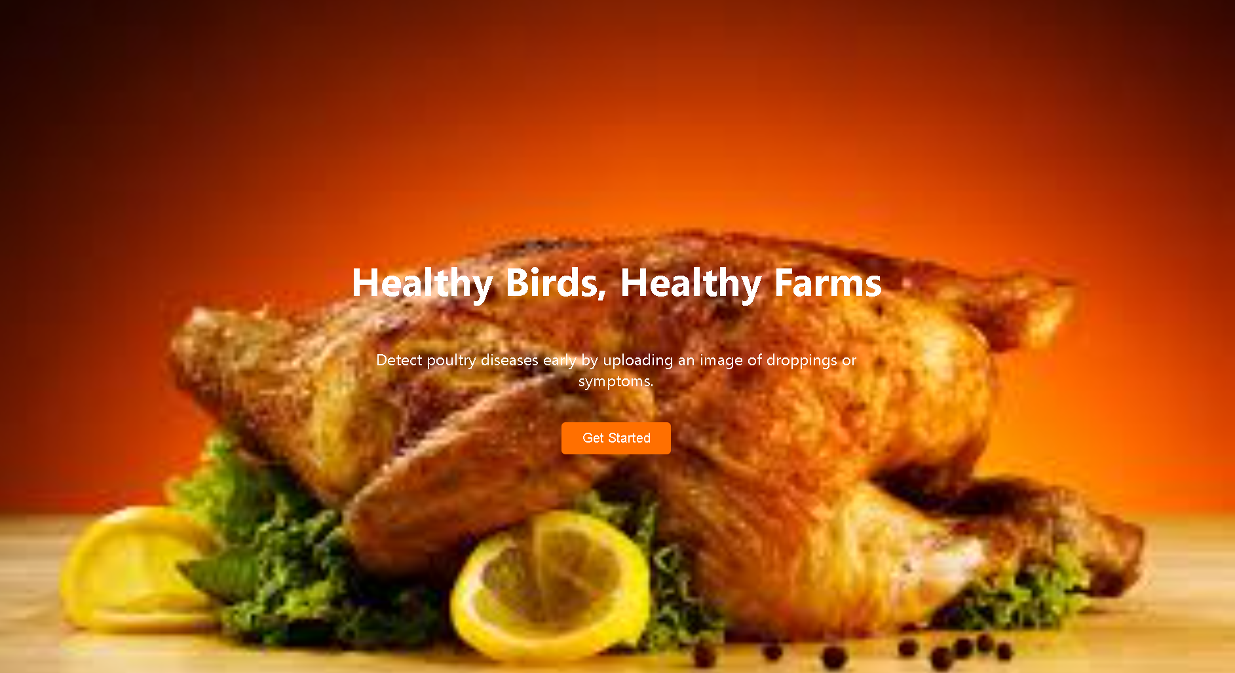

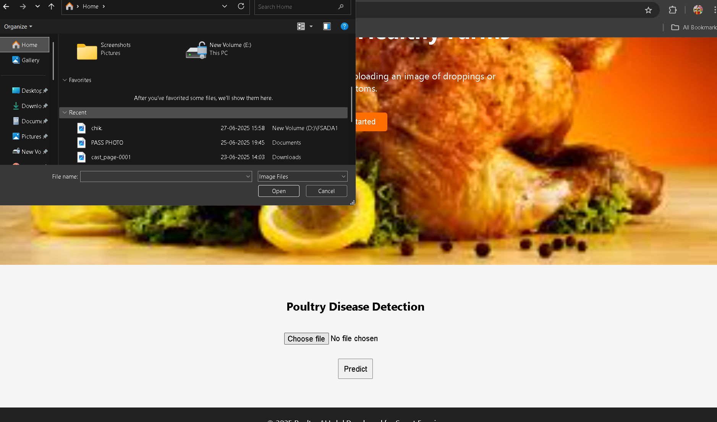

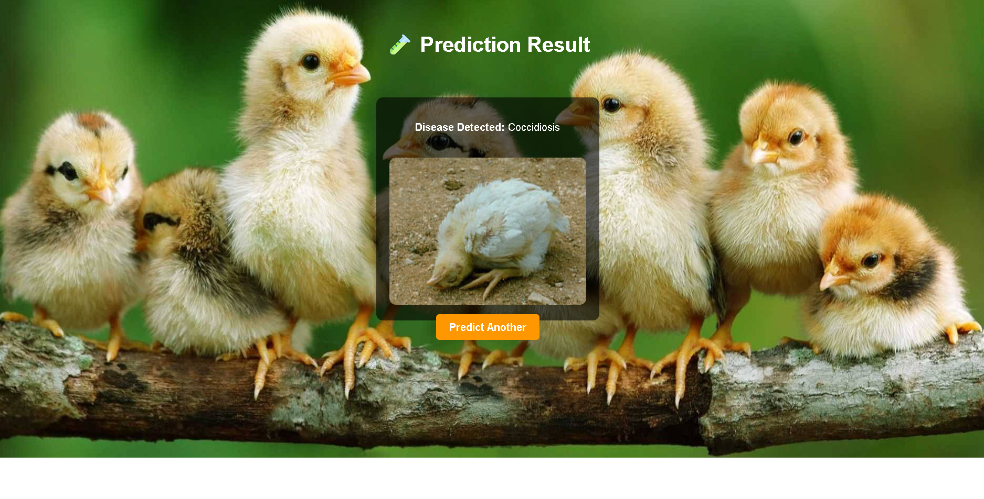

# 8. ADVANTAGES & DISADVANTAGES

**Advantages:**  
- Early disease detection  
- Offline availability  
- Multilingual support  
- Empowers farmers  
**Disadvantages:**  
- Requires good quality images  
- Initial data collection and training effort

# 9. CONCLUSION

The development of the "Real-Time Poultry Disease Detection System" using transfer learning demonstrates how artificial intelligence can be effectively applied in the agricultural sector to address real-world challenges. This project has successfully created a mobile-compatible, image-based disease detection tool that empowers poultry farmers—especially in rural areas—to diagnose diseases early, take preventive measures, and minimize economic losses.

By leveraging pre-trained models and customizing them for poultry disease classification, the system offers fast, accurate, and accessible results. Features like multilingual support, offline access, and simple interfaces ensure usability even for non-technical users. Overall, the project bridges the gap between modern AI technology and traditional farming practices, promoting better poultry health management and contributing to food security.

# 10. FUTURE SCOPE

While the current system successfully identifies poultry diseases through image-based analysis, there are several promising directions to enhance its capabilities:

Support for More Diseases & Bird Types: Extend the model to detect a wider range of poultry diseases and apply it to other bird breeds or livestock.

Live Video Monitoring: Integrate with CCTV or drone feeds for real-time disease tracking in large-scale poultry farms.

Farmer Education Module: Add in-app training materials and tutorials to educate farmers on best practices and early disease signs.

Vet Chat & Telemedicine Integration: Allow users to consult with verified veterinarians directly through the app.

IoT Device Integration: Use temperature, sound, or movement sensors to detect behavioral changes indicating disease.

Multilingual Voice Assistance: Implement speech-based support for farmers with low literacy levels.

By expanding in these directions, the system can evolve into a comprehensive digital health platform for animal agriculture, maximizing its impact on productivity, food safety, and economic stability in farming communities.

# 11. APPENDIX

**Source Code:**

Source Code: import os

import numpy as np

from flask import Flask, render_template, request

from keras.preprocessing.image import load_img, img_to_array

from tensorflow.keras.applications.resnet50 import preprocess_input

import tensorflow as tf

app = Flask(__name__)

# ✅ Load the ResNet50-trained model

model = tf.keras.models.load_model("best_model.h5")

# Class labels (in training order)

class_labels = ['Coccidiosis', 'Healthy', 'New Castle Disease', 'Salmonella']

# Folder for uploaded images

UPLOAD_FOLDER = os.path.join('static', 'uploads')

os.makedirs(UPLOAD_FOLDER, exist_ok=True)

@app.route('/')

def home():

    return render_template('index.html')

@app.route('/about')

def about():

    return render_template('about.html')

@app.route('/contact', methods=['GET', 'POST'])

def contact():

    success = False

    if request.method == 'POST':

        name = request.form['name']

        email = request.form['email']

        message = request.form['message']

        # 👉 (Optional) Save, log or process the message here

        success = True

    return render_template('contact.html', success=success)

@app.route('/predict', methods=['GET', 'POST'])

def predict():

    predicted_class = None

    uploaded_image_path = None

    if request.method == 'POST':

        file = request.files['pc_image']

        if file:

            filename = file.filename

            uploaded_image_path = os.path.join(UPLOAD_FOLDER, filename)

            file.save(uploaded_image_path)

            # ✅ Preprocess image for ResNet50

            img = load_img(uploaded_image_path, target_size=(224, 224))

            img_array = img_to_array(img)

            img_array = np.expand_dims(img_array, axis=0)

            img_array = preprocess_input(img_array)

            # ✅ Predict

            prediction = model.predict(img_array)

            predicted_class = class_labels[np.argmax(prediction)]

    return render_template(

        'predict.html',

        predict=predicted_class,

        uploaded_image=uploaded_image_path if predicted_class else None

    )

if __name__ == '__main__':

    app.run(debug=True)

**Dataset Link:** <https://drive.google.com/file/d/1c1ery9LY7Q3ommVjT_tcxBVVe1GnqBug/view?usp=sharing>

**GitHub Link:**

**ProjectDemo Link:**